**IDEATION PHASE**

**DEFINE THE PROBLEM STATEMENTS**

­­­

|  |  |
| --- | --- |
| **DATE** | **16 October 2022** |
| **TEAM ID** | **PNT2022TMID14113** |
| **PROJECT NAME** | **IOT BASED SMART CROP PROTECTION SYSTEM FOR AGRICULTRUE** |
| **MAXIMUM MARKS** | **2 MARKS** |

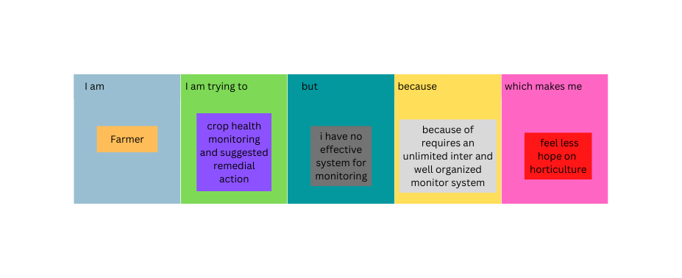

|  |  |  |  |  |  |  |
| --- | --- | --- | --- | --- | --- | --- |
| **S.no** | **Problem statement** | **I am (customer)** | **I am trying to** | **But** | **Because** | **Which makes me feel** |
| 1 | Problem statement | Farmer | Monitoring the growing condition | It involves risk on related equipment and understand the use of technology | Requires more knowledge and skills | Irritated |
| 2 | Problem statement | Farmer | Smart and precision irrigation | Climates changes to increased maintenance of channels | Purchasing and installing costs high | Suitable for mass crop protection |

|  |  |  |  |  |  |  |
| --- | --- | --- | --- | --- | --- | --- |
| **S.no** | **Problem statement** | **I am (customer)** | **I am trying to** | **But** | **Because** | **Which makes me feel** |
| 3 | Problem statement | Farmer | Protect crop from wild animals and Birds | We cannot monitor the  Crops Each and every minute | It requires  Application and Iot devices | Suitable for mass crop protection |